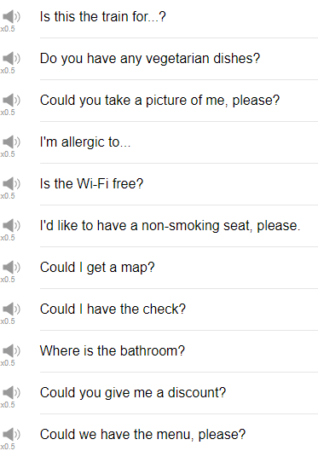

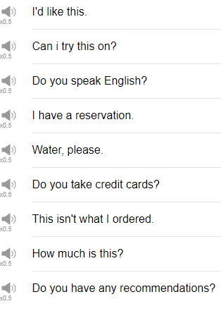

|  |
| --- |
| Yeah! Vamos a la playa! Now we're going to the beach! |
| Hi, everybody, welcome back to Top Words. My name is Alisha, and today we're going to be talking about 20 travel phrases that you should know. So let's go! |
| 1. Do you have any recommendations? |
| The first phrase is “do you have any recommendations?” This is great to use when you get to a restaurant where you don't know what the food is, you don't know anything about the local cuisine, or you're just feeling a little bit adventurous; you can ask the waitstaff “do you have any recommendations?” |
| 2. How much is this? |
| This is useful when you're out shopping or when you're in a restaurant, and the price is not clearly marked or something is not clear to you, so you can ask “how much is this?” |
| Usually, when you point to something, I would recommend, like, pointing to the menu, pointing to an item, “how much is this?” |
| 3. I’d like this. |
| You can point to something and say, I'd like this. If you want to say, I'd like one, for example, I don't know, you're getting beer, I'd like one of these. If, however, you're in a situation where you can't point, you can say, “I’d like ten of the blah blah blah.” |
| I'd like ten of blue t-shirts, please. |
| 4. Can I try this on? |
| It's useful when you're shopping for clothes. So you found something that you'd like to try, just ask the staff "can I try this on?" |
| You can just say "I want to try this on" if you like. |
| 5. Do you speak English? |
| You might get asked this phrase, so you should say, if you're watching this videos you'd probably say "yes," or you can say "yes, a little." If you're not feeling very confident, if you're watching this video and you're understanding this part and you say "no" then that's a little strange. |
| 6. I have a reservation. |
| Usually, the staff will greet you and you can say I have a reservation. |
| Hello, I have a reservation, it's at 7 o'clock, the name is Alisha. Usually, we say "the name is" or "it's under," meaning the reservation is under my name or it's for (name), or it's in (name). |
| 7. Water, please. |
| Depending on which country you're from, water may or may not automatically be brought to your table when you're in a restaurant. If you would like more water, however, you can say "water, please" to make it a little more polite. I would like, wave at the waitstaff and say "could I please have some more water?" |
| 8. Do you take credit cards? |
| In case you're not sure if the shop that you're in will accept credit cards or debit cards, you can ask them "do you take credit cards?" And so it doesn't mean "do you take" meaning are you going to take my card, but this "take" means do you accept credit cards. |
| 9. This isn't what I ordered. |
| So if you're at a restaurant, you order steak and you get lobster instead; you can look at it and go "ah! this isn't what I ordered." |
| Be careful though, saying this politely if you look at the waitstaff and you say this isn't what I ordered, they're going to be like, I don't know, just be a nice customer. "Excuse me, but I don't think this is what I ordered" or "this isn't what I ordered, can you please check?" |
| 10. Could we have the menu, please? |
| If for some reason you don't receive a menu when you come to the table, you can again just wave to a member of the staff and say "could we have the menu, please?" |
| 11. Could you give me a discount? |
| Could you give me a discount means "I would like a cheaper price." Essentially, it depends on which country you're in, if haggling or bargaining, meaning talking to the seller to try to reduce the price, my family didn't bargain we didn't haggle, so I don't haggle depends on you and your culture. But just, yeah, just be aware of the culture that you're in, and the place that you're in before you ask this question. |
| 12. Do you have any vegetarian dishes? |
| Ah! This is useful! Some people have specific eating requirements or eating needs, maybe food allergies, for example. You can replace vegetarian with the specific dietary requirement that you have, "do you have any vegan dishes?" "Do you have any gluten-free dishes?" "Do you have any low-fat dishes?" "Do you have any low-carb dishes?" "Do you have any fish-free dishes?" |
| Do you have any... |
| 13. Could you take a picture of me, please? |
| If you are in a location where you would like to take a picture but you don't want to do a selfie, or you don't have a selfie stick or whatever, you want someone else to take a picture of you, a stranger that you don't know, you can ask them "could you take a picture of me, please?" Or "Excuse me, would you mind taking a picture of me, please?" |
| 14. I'm allergic to... |
| If you have a food allergy or even an allergy to a medicine, this is the phrase you can use to explain that. I'm allergic to wheat, or I can't eat wheat, for example. |
| 15. Is the Wi-Fi free? |
| Meaning "can I use the Wi-Fi free of charge?" Keep in mind some places have a password that you have to ask the staff for, so you can say "is the Wi-Fi free?" If they say yes, you can then follow that up with "can I have the password?" |
| 16. I'd like to have a non-smoking seat, please. |
| So when you go to a restaurant you have an option between smoking and non-smoking sections; the staff will say smoking or non-smoking. You can say I'd like to have a non-smoking seat, please. Quite honestly though, the most natural response is just to say "non-smoking." |
| 17. Could I get a map? |
| Maybe it's a map of the subway system for the city that you're in or maybe it's a map of the area around your hotel, you could say "could I have a map" as well. |
| 18. Could I have the check? |
| You're finished at the cafe, you're finished at the restaurant, and it's time to leave, it's time to pay; so you say to the waitstaff "excuse me, could I have the check?" Another more common expression, perhaps, is "excuse me, check please." You might also hear "bill." |
| Excuse me, can I have the bill? |
| 19. Where is the bathroom? |
| Very important question, if you're traveling in America we don't really use the word toilet or washroom very much, we use bathroom or restroom to talk about toilet facilities. "Excuse me, can you tell me where the bathroom is?" or "excuse me, I'm looking for the bathroom," or "I'm looking for the restroom." |
| 20. Is this the train for...? |
| Or is this the train that goes to...? to confirm with someone that I'm indeed on the correct train line. |
| If I say, is this the train bound for San Francisco? You can use that to check if you're correct. |
| So that's the end those are 20 travel phrases that you can use when you're traveling in an English speaking country. Give them a try, I hope that they go well for you, of course, there are many different variations on these themes so be sure to experiment a little bit. |
| Thanks very much for watching this episode of Top Words, and we will see you again soon. Bye! |
| The things that I do before I travel to a country where I cannot speak the language, I actually learned numbers. Ok! Fin! |